PR NUMBER Sizes: Large 30, medium 30, free size 40. Colours 50 White, 50 Orange
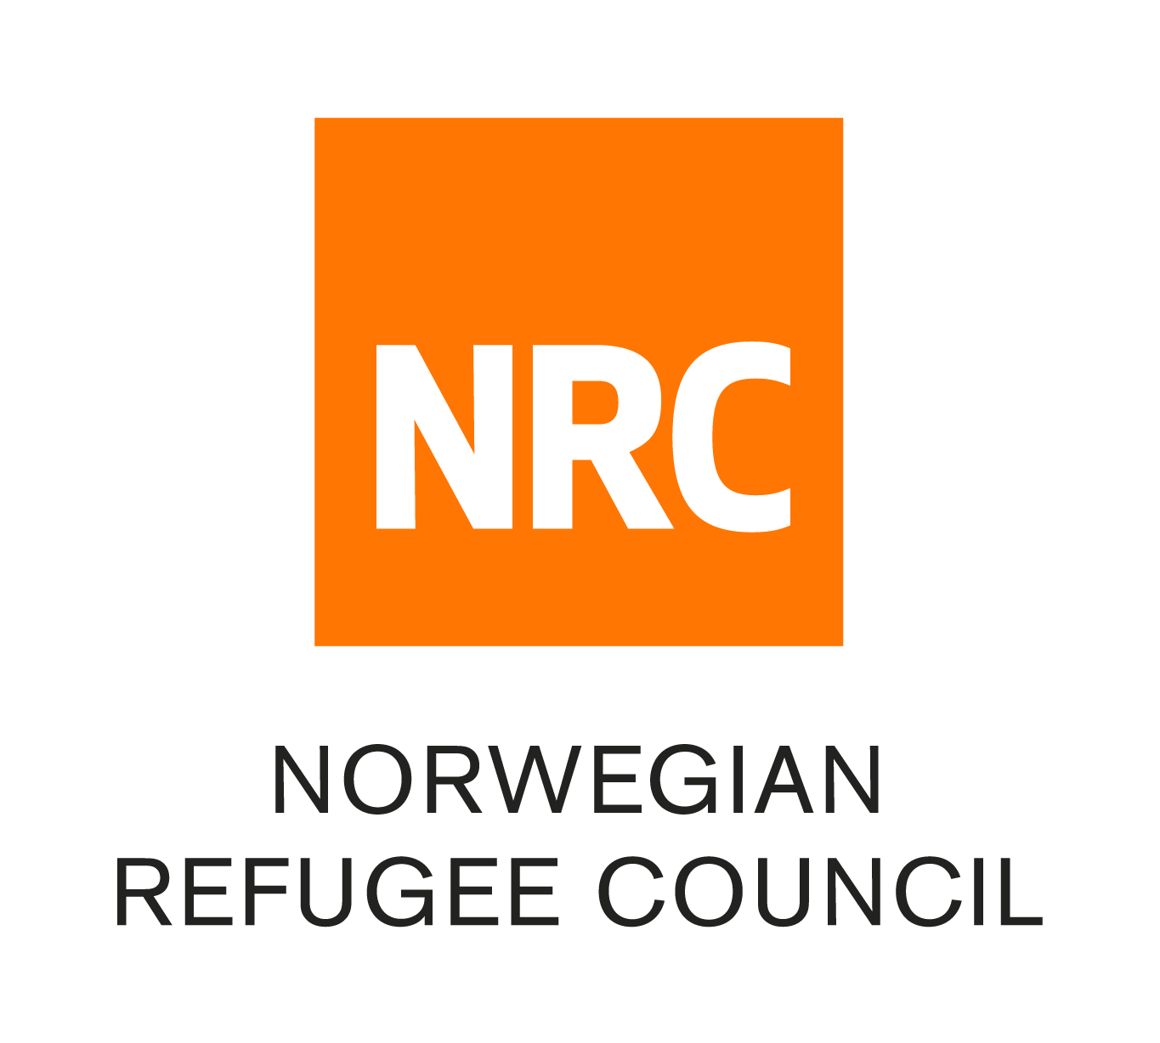

World Water Day 2023

Theme: Groundwater: Making the Invisible Visible

